Design Document
Group A - Team Red Panda



7 November, y

Peter Grypma
Chris Hobbs
Hizkia Mertadiwangsa
David Wu

Table of Contents

Revision History 2

Guidelines 2

Development Tools 2

Legal Issues 2

System Diagrams 2

UML Diagrams 2

Word Scramble UML Diagram 2

Missing Letters UML Diagram 2

Decision Network Diagrams 2

Generic Menu Network 2

Data Requirements 2

Game Content Data 2

Settings Data 2

User Interaction 2

Feature Priority 2

GUI 2

Data 2

Game Engine 2

Revision History

Revision | Status | Publication/Revision Date | By
1.0 | Created | 7 October, 2012 | Chris Hobbs
2.0 | Revised entire document for HW2 resubmission | 24 October, 2012 | Chris Hobbs

Guidelines

Development Tools

Team Red Panda will utilize the following tools throughout the development process of their apps:

- Primary IDE: Xcode v4.5.1 by Apple Inc.
- Version Control: GitHub.com by GitHub Inc.
- StackOverflow.com by Stack Exchange Inc.
- Photoshop CS5 by Adobe
- Illustrator CS5 by Adobe
- Operating Platform: iOS 6.0 by Apple Inc.
- Initial Testing: iOS Simulator v6.0(build 358.4) by Apple Inc.
- Final Testing: Apple iPhone 4 GSM (Telus)
- Apple iOS Development Guidelines

Legal Issues

Any possible legal issues may come by inadvertently using a registered trademark or copyrighted material as well as possibly reproducing any patented methods of data manipulation. There may also be issues with privacy laws especially with regards to the Children’s Online Privacy Protection Act (COPPA).

System Diagrams

The following diagrams show how the applications are structured. There are two types of diagrams contained in this section. There are UML diagrams which show how the applications’ classes interact with each other. There is also a decision network diagram that displays all the possible choices and outcomes while navigating through the applications’ menus.

UML Diagrams

In the UML diagrams (Figures 1 & 2) there are symbols that denote different parts of the application and how they interact with each other. Each box represents an individual class. The class box is then split into 3 parts. The first part is the title of the class, the second part is the definition of the class variables, and the third part is the definition of the class methods. We then have a few different arrows and lines. Arrows with a dotted line denote a one way dependency, in other words the class that the arrows comes out of uses methods from the class the arrow is going into. Arrows with a solid line denote a 1 way interaction, which means that the class the arrow is coming out of interacts with the class the arrow is going into but not vise versa. In the case of the view controller classes this is caused by a one way transition from one screen to another. Solid lines denote a bidirectional interaction, this means that the two classes interact with each other. In the case of view controllers, this means that you can transition back and forth between the two screens.

Word Scramble UML Diagram

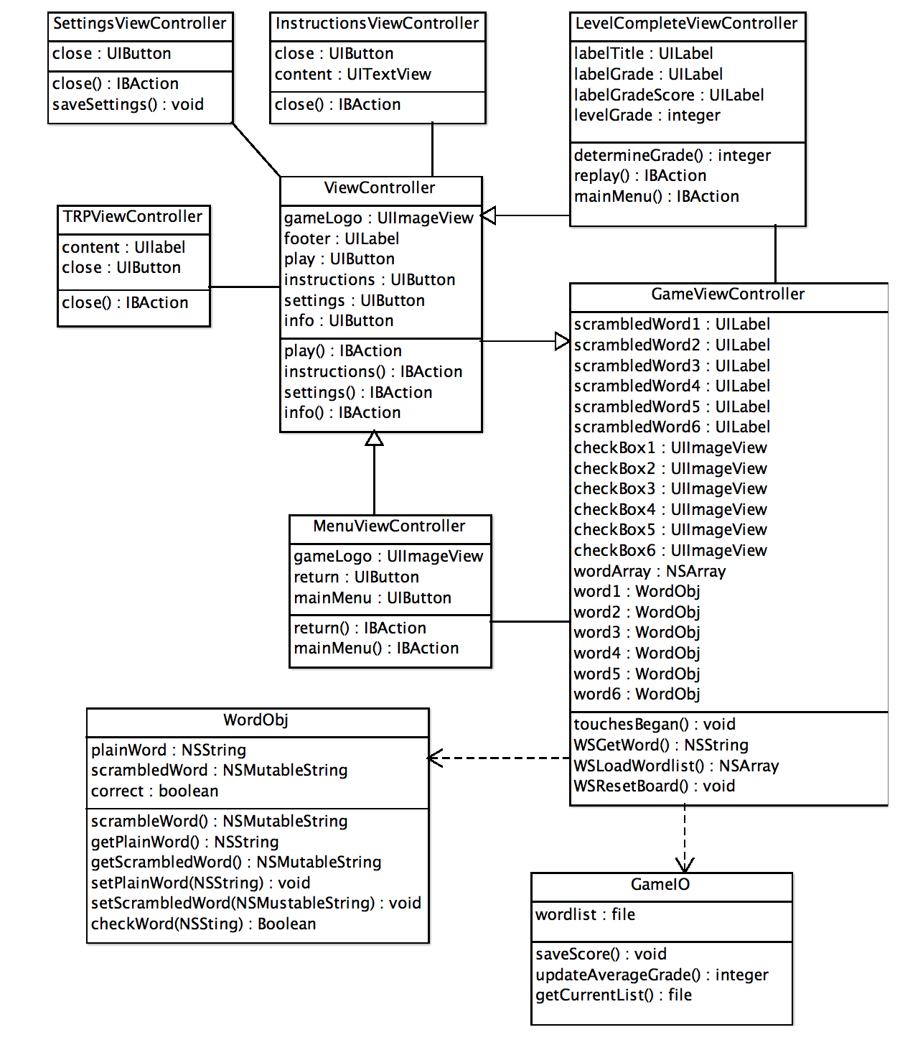
Figure 1 shows the different classes used in Word Scramble and how they interact with each other. Some actions and UI elements may not appear in this UML diagram or may be place holders for methods that are not actually in the class. This is because some of the UI elements which are not changed during the runtime of the game are not declared in any of the classes but the code for them is implemented during compiling by Xcode. There are also actions such as menu navigation where we have added placeholder methods to the UML diagram as it is a method of that class however the code for it is generated and inserted at compile time so it will not appear in the source code.
Figure 1

Missing Letters UML Diagram

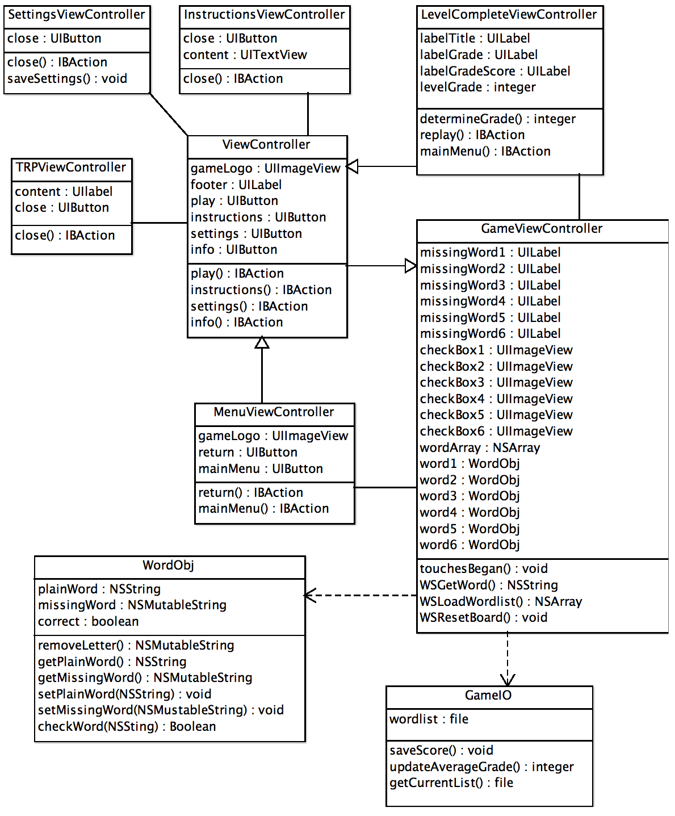
Figure 2 shows the different classes used in Missing Letters and how they interact with each other. This looks very similar to the Word Scramble diagram because the operation and main components of the games are identical, it is merely the implementation of those components that changes. As with Figure 1, some actions and UI elements may not appear in this UML diagram or may be place holders for methods that are not actually in the class.
Figure 2

Decision Network Diagrams
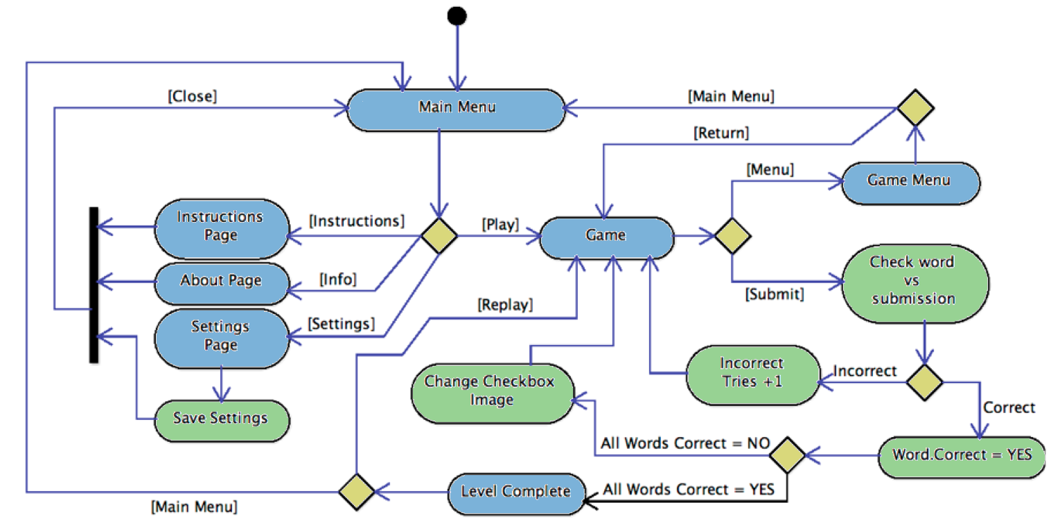
For the decision networks, the black dot denotes the beginning of the network when the program is initialized. The green and blue bubbles represent the states of the program. Blue is the state when screen is displayed, green is the state when and action occurs. We then have yellow diamonds that indicate that there are multiple possible outcomes from the current state. The arrows going between states represent the stimuli that cause the program to transition to the next state. Stimuli enclosed in square brackets represent UI Button presses. The stimuli without the square bracket indicates boolean stimuli (Yes or No).
Figure 3

Generic Menu Network

Figure 3 shows all the possible navigation paths and event results possible in the game. This is the same for both Word Scramble and Missing Letters as they use the same menu layout and events.

Data Requirements

Game Content Data

The content for the game will be hosted on an external server and will require an internet connection to access the most up-to-date data. The data on the server for version 1 will be a plain text file containing words. They will be in a list format with line breaks separating the words as in the example below:

In version 2 the wordlist format will be changed to the JSON format to support direct input from SynPhony. The actual layout of the JSON file is to be determined. When a user opens the app, it will check to see if they have an active internet connection. If an active internet connection is present, the app will then download the current data file and store it on the device. If no internet connection is present, the app will load up with the data file that is currently stored on the device.
Word₁
Word₂
Word₃
Word₄
Figure 4 - Example wordlist.txt
{"UserHistory": {
"Username": "Example User",
"AverageGrade": 57,
"GradeHistory": [
{"Grade": 88},
{"Grade": 56},
{"Grade": 91},
{"Grade": 73},
]
}}

Figure 5 - Example user data file

In version one, there will be a single universal data file that the app accesses. In following versions it will access user specific data based on username which will be stored on separate locations on the data server. The app will then go to the specific user’s directory and download their specific file.

There will also be a local JSON datafile which stores statistics such as the average grade.

Settings Data

The settings set in the settings screen of the app will be stored in the settings.config file of the app. This will include settings such as username and password, among other possible settings in future versions.

User Interaction

The user will interact with the system through the default iOS keyboard as well as with the device’s touch interface. There is no special hardware required to operate either of the apps.

Feature Priority

The tables below map out the the planned implementation schedule for the features of our apps by version number. They are also split into different categories by the type of feature. Yellow boxes indicate partial implementation of a feature. A feature may be partially implemented when that feature requires other features from future versions to be completed to function to it’s full planned potential. Green boxes indicate features that will be implemented during the specified version.

GUI

Version | Main Menu | Instructions Screen | Level Finished Screen | Settings Screen | Statistics  Display | Improved Graphics | Pause Menu
1 |  |  | Partial¹ | Partial²
2 |  |  | Full | Full

3
¹Lacking level grade, and average grade display
²Lacking specific username and password fields

Data

Version | Wordlist | Wordlist Format | Saved Settings | User Statistics  History | Data Server | Performance Enhancements | Dynamic Wordlists⁴
1 | Generic ¹ | TXT | Partial² |  | Universal³
2 | User Specific | JSON | Full |  | User Specific
3
¹Initial version will use a generic word list for all users as a proof of concept but will use user specific word lists at a later date
²Lacking username and password settings as that feature is implemented in version 2
³Universal hardcoded file location for generic word list, version two will use dynamic URL based on the username to access the appropriate wordlist
⁴Dependent on SynPhony API abilities

Game Engine

Version | Game Data Generation¹ | Core Game Engine | Game Statistics | User Statistics  History | Performance Enhancements | Dynamic Game Generation³
1 |  |  | Partial²
2 |  |  | Full
3
¹This when the words for the game are scrambled or letters are removed (as appropriate)
²Basic info such as total number of guesses will be displayed but more in-depth statistics come in version 2
³Dependent on SynPhony API Abilities

